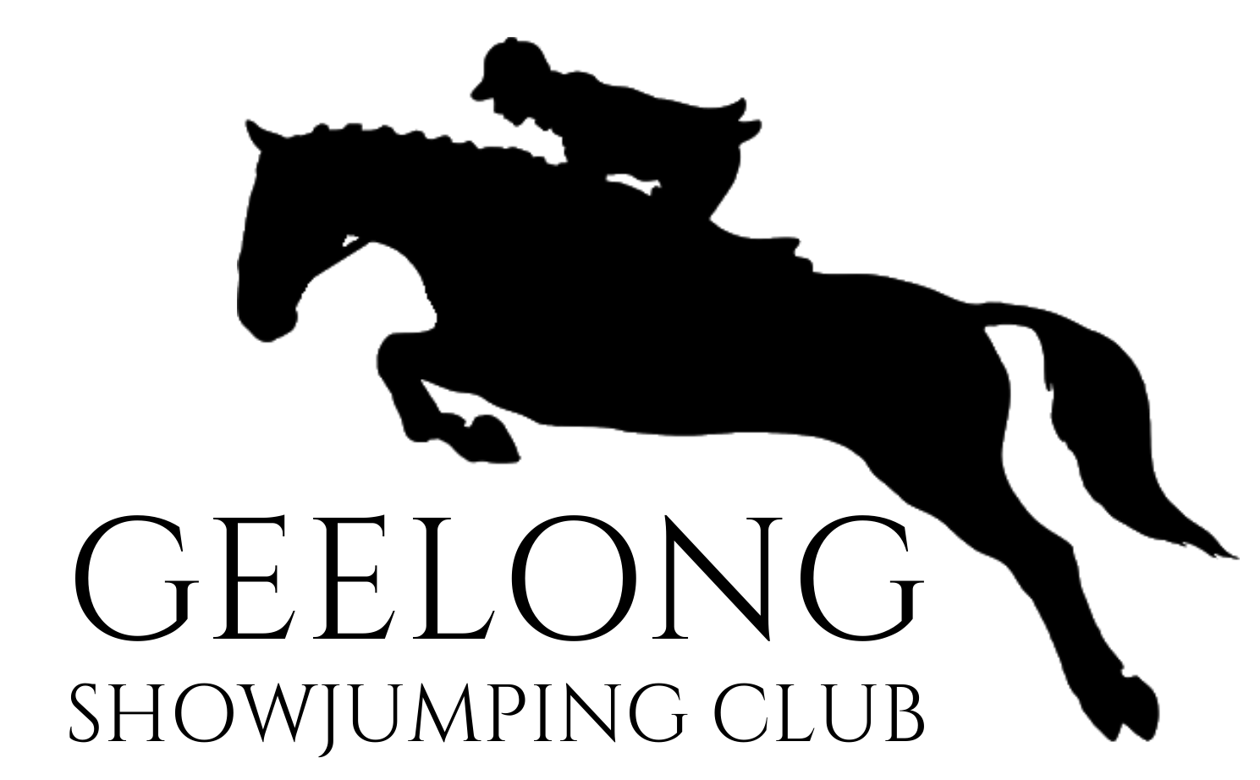

STATEMENT OF COMMITMENT TO CHILD SAFETY
Geelong Showjumping Club is committed to safety and wellbeing of all children and young people. This will be the primary focus of our care and decision-making. Geelong Showjumping Club has zero tolerance for child abuse. Geelong Showjumping Club is committed to providing a child safe environment where children and young people are safe and feel safe, and their voices are heard about decisions that affect their lives. Particular attention will be paid to the cultural safety of Aboriginal children and children from culturally and/or linguistically diverse backgrounds, as well as the safety of children with a disability.
Every person involved in Geelong Showjumping Club has a responsibility to understand the important and specific role he/she plays individually and collectively to ensure that the wellbeing and safety of all children and young people is at the forefront of all they do and every decision they make.
In its planning, decision-making and operations Geelong Showjumping Club will:
1. Take a preventative, proactive and participatory approach to child safety;
2. Value and empower children to participate in decisions which affect their lives;
3. Foster a culture of openness that supports all persons to safely disclose risks of harm to children;
4. Respect diversity in cultures and child rearing practices while keeping child safety paramount;
5. Provide written guidance on appropriate conduct and behaviour towards children;
6. Engage only the most suitable people to work with children and have high quality staff and volunteer supervision and professional development;
7. Ensure children know who to talk with if they are worried or are feeling unsafe, and that they are comfortable and encouraged to raise such issues;
8. Report suspected abuse, neglect or mistreatment promptly to the appropriate authorities;
9. Share information appropriately and lawfully with other organisations where the safety and wellbeing of children is at risk; and
10. Value the input of and communicate regularly with families and carers.
Geelong Showjumping Club adheres to the Australian Sports Commission Child Safe Policy,
1 January 2021.

