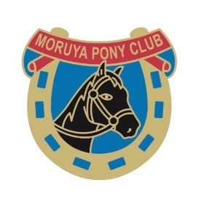
Moruya pony club gymkhana
28.5.2023
Moruya pony club will be holding our Annual gymkhana on Sunday the 28.5.23, at the Moruya Pony club grounds Noads Drive, Moruya. Gear check 8.30am for a 9am start.
Camping is available at a cost of $10 per family, hot showers are available but no powered sites, Yards are available.
Entries are on global entries online, entries close on the 22.5.23. Cost is $20 per horse.
A second non competitive horse (HC) maybe allowed if numbers permit, this horse must be selected at the time of entry.
Ribbon’s will be awarded to 5th place plus champion and reserve champion in each age group, Novice rider’s points do not count towards champion.
Classes will be run in the following age groups
Assisted Unassisted
Under 9 years 9 under 11 years Advanced
11 under 13 years Advanced 13 under 15 years Advanced
15 under 17 years Advanced 17 under 26 years Advanced
9 under 13 years Novice 13 under 26 years Novice
Classes include: Riding class, Handler, Bareback and best presented
Showjumping : run in grades intro, E under 13 years , E over 13 years, D grade, C grade, B grade , A grade
Jackpot and Immediate jump off
Sporting : 2 chances fastest time counts * denotes counts towards points
Bending * Western Bending Keyhole
Twisty tee* In and out of the paddock* Barrels
All pony club NSW rules apply, please make sure you understand the rules before entering. All riders must be financial members of pony club and graded on the horse that is entered, this will be checked at time of entry. All riders must wear full pony club uniform long sleeve shirt, tie etc.
No Dogs permitted , No smoking on the grounds
All enquiries to Michelle Nickson michellenickson@bigpond.com or 0410453191

