Table C (Article 239)
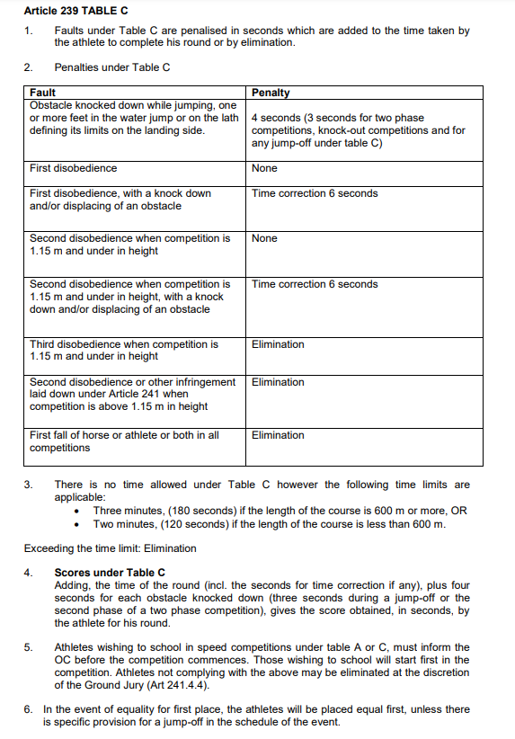

AM7 (Article 245.3)
