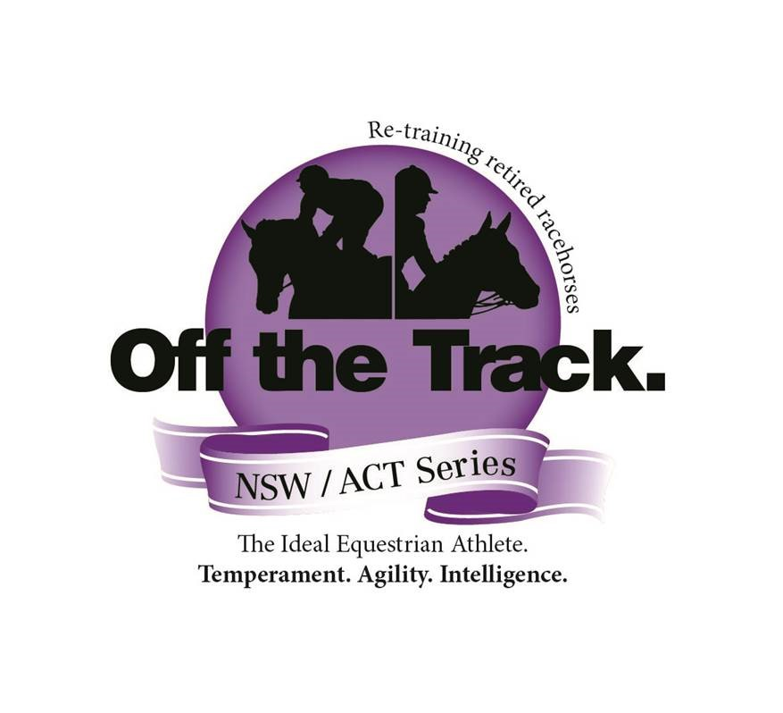
Off the Track NSW/ACT Series

- The event is open to all thoroughbreds that have officially raced or trailed either locally, nationally or internationally. All horses are required to be 3 years and over and over 14.2hh. All horses will be registered with a recognized studbook eg: Aust. Studbook/NZ Studbook/Irish Studbook. As determined by Racing Victoria in July 2018, a separate OTT category is to include horses that are Stud Book registered but have not trailed or raced. It is up to individual show societies to clarify these classes in the schedule. *Registrations will be checked.
- Racing name to be used.

- Qualifying Shows must be affiliated with Agricultural Societies Council of NSW Ltd, Show Horse Council of Australasia Inc, Equestrian Australia or a relevant breed society.

- OTT Qualifying class/es will be judged as a ridden class.
4B: 2022 - Introduction of a Led Series – due to so many shows already holding a Led OTT class. Led and Ridden are two different series.

- Once a qualifier has been won, the horse cannot compete in other qualifiers within the season. Horses that have achieved Runner Up are able to continue in the competition unless they win an OTT Qualifier class. The winner and runner up of each qualifying class will be eligible to compete in the State Final. Winners will be posted on the FB page.

- Horses will be judged as a good example of a Thoroughbred rather than riding horse/hunter types with the following being taken into consideration.
• Thoroughbred qualities
• Conformation
• Manners, paces and performance
• Injuries caused through racing such as blemishes are allowed

- Judges decision is final in qualifiers and final.

- Horse and Owner must reside in NSW or ACT to compete in the Off the Track NSW/ACT Series.

- The final to be held at the ‘Thoroughbred Spring Fair’ at the end of each year eg: November

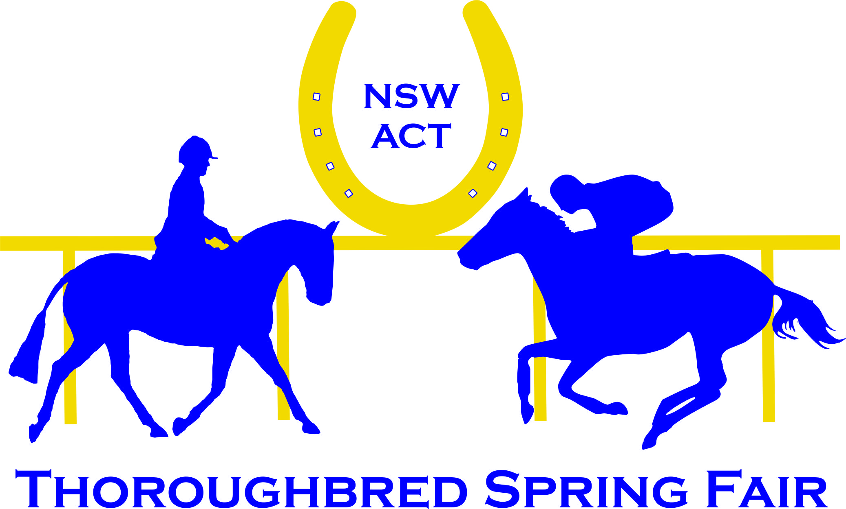
0412 469200

